**Irrigation costs and crop production: Integrated assessment of increasing irrigation costs on land-use change and crop cultivation in India using partial equilibrium modelling**

**Introduction**

Food production in the world depends on water to a large extent, particularly groundwater. Millions of farmers in the world use irrigation to cultivate major crops, particularly rice and wheat (Dalin et al., 2017). India is the largest consumer of freshwater (ground and surface water) globally, 91% of which

is withdrawn for food production (FAO, 2016). Figure 1 below demonstrates India as an outlier in excessive groundwater extraction (Aeschbach-Hertig & Gleeson, 2012).

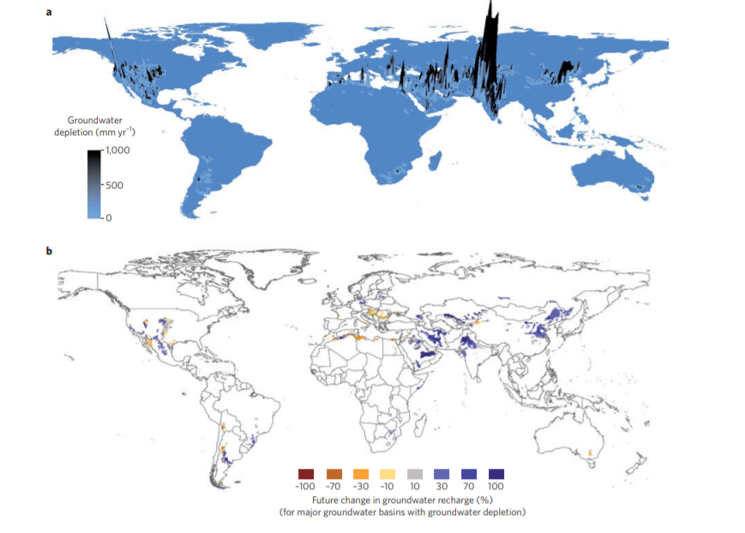

Figure 1: Intensive use of groundwater (Aeschbach-Hertig & Gleeson, 2012)

Excessive groundwater consumption for India is focused on cereal production with wheat and rice production consuming 80.6% of total agricultural water use (Jain et al., 2017; Kayatz et al., 2019). While rice has always been a water-intensive crop, wheat has witnessed an increase in water usage over the last few years. Figure 2 below depicts the continuously increasing area particularly under wheat irrigation in India over the years.

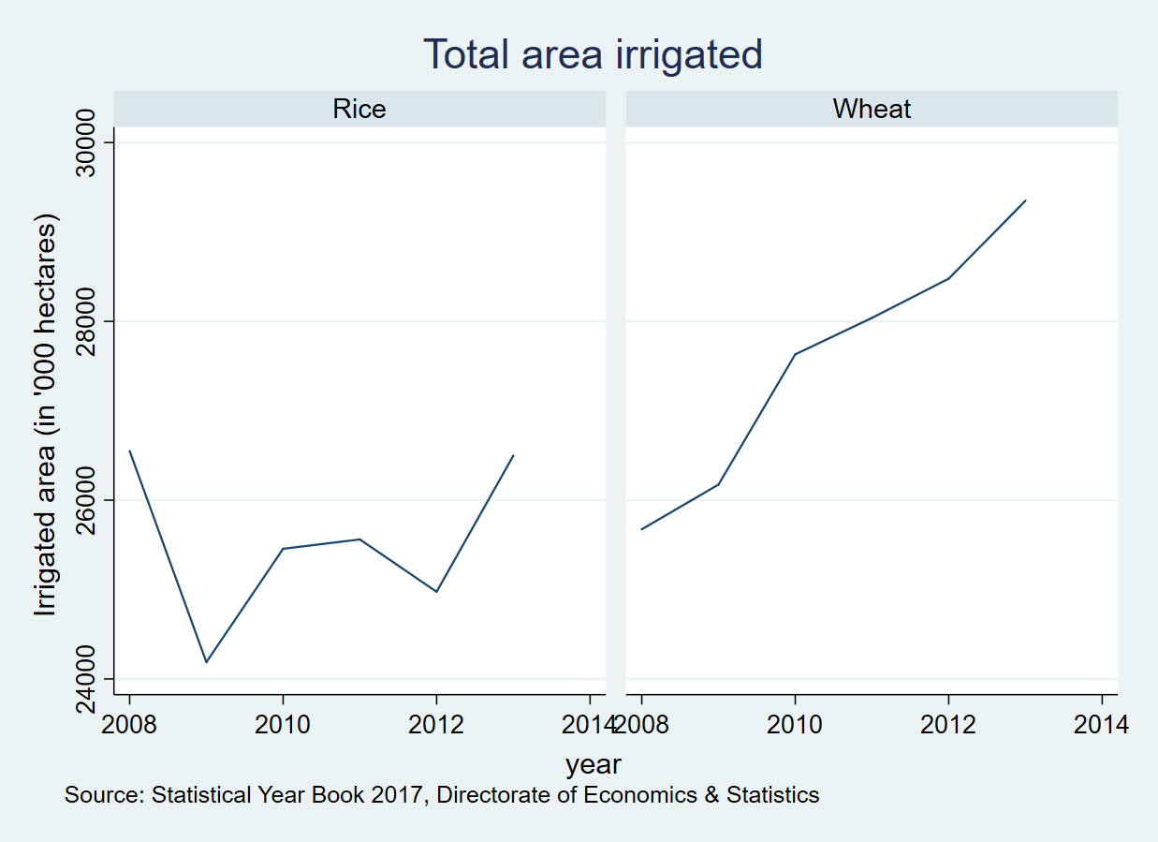

As a result, groundwater depletion has become a cause of concern for India. The causes of excessive groundwater utilization in India, however, are deep-rooted.

**Background**

The Green Revolution began in the mid-1960s with a focus on increased cereal crop production to meet India’s growing food demand. This was a major turning point in India’s agriculture as new high yielding varieties were being adopted, with accompanying use of fertilizers that offered benefits with irrigation. To ensure farmers reaped the benefits of new technology and information, huge investments were undertaken to improve farmer’s access to irrigation, including groundwater extraction. An irrigation subsidy seemed appropriate to provide the relevant support to the farmers. Expectedly, these high irrigation subsidies have resulted in continued expansion of groundwater irrigation in India over the years. Between 1995 and 2004, groundwater extraction in India increased by 18 percent and the number of over-exploited districts - those in which annual demand exceeds annual recharge - grew by 18 percent (Badiani & Jessoe, 2014). Evidence suggests that India witnessed increased agricultural yields, lower food prices of cereal crops and an increased demand for agricultural labour mostly due to growth in groundwater irrigation that was fueled by electricity subsidies (Badiani et al., 2012; Briscoe & Malik, 2006; Scott & Shah, 2004). As a result, irrigation is not demand-driven anymore, but rather dependent on the electricity supply or lower tariffs.

India ranks the world’s highest in agricultural subsidies. A large chunk of these subsidies are towards agriculture – fertilizers, food and energy for irrigation. Per some estimates, power subsidies in agriculture in India are approximately 12 billion USD in 2015-16 while irrigation subsidies were 2 billion USD in 2013-14 (Ramaswami, 2019). These subsidies are aimed to help the small and marginal farmers to reduce their costs of irrigation and help them overcome the vagaries of monsoon. India has faced deficit rainfall in the last 13 out of 18 years, with seven drought years. It is also the world’s largest consumer of groundwater where up to 70% of agricultural production and 50% of the population depend on it (The World Bank and Government of India, 1998). As a result of these subsidies, total irrigated area in India nearly tripled to 33,100,000 ha between 1970 and 1999 (Zaisheng et al., 2006) and continues to rise thereby putting pressure on the water resources in the country.

Agriculture and water are state subjects in India and the local state governments are the authority in decisions on the usage of both. They usually play a role in determining the energy pricing for the agricultural grid. As a result, sub-national policies on electricity pricing for agriculture are different for different states in India. Statistics from the Central Groundwater Board reveal the trends in groundwater extraction status across various states in India. 21% of groundwater units in India were found to be either at critical or over-exploited state (Central Ground Water Board, 2019). In the same report, it is presented that while the overall stage of ground water development in the country is 63%, the states of Delhi, Haryana, Punjab and Rajasthan have over 100% rate of extraction, implying that in these states the annual groundwater consumption is higher than their annual extractable groundwater resources. Rodell et al., (2009) undertook an assessment of groundwater depletion rates of these three states (including Delhi) using terrestrial water-storage observations from NASA GRACE satellites and found that from August 2002 to October 2009, groundwater depletion in these states was equivalent to a net loss of 109 km3 of water. This extraction is almost double the capacity of India’s largest surface-water reservoir. Similar analysis in the Indo-Gangetic Plain, the largest reservoir in India, has found that groundwater depletion has been prevalent due to exploitative abstraction where groundwater storage levels continued to decline until 2009 and have stabilized thereafter (Tiwari et al., 2009; Yi et al., 2016).

Decreasing groundwater levels in these regions has reduced the water table further, thereby increasing the energy costs of extraction for the farmers. In their analysis of groundwater depth and electricity consumption for pumping, Barik et al., (2017) found a negative correlation between groundwater storage from 2008-09 to 2011-12 and an increase in electricity consumption (R = -0.86). Consumption of electricity can be used as a safe proxy for “electricity used for pumping groundwater” as most other mechanization activities for agriculture use diesel (Scott & Shah, 2004). Water pricing for agriculture through electricity tariffs is therefore seen as a powerful tool in influencing groundwater usage in specific regions. Bhanja et al., (2017) undertook a case study of Gujarat, India, whereby they used the electricity reduction information in HTS simulation of Gujarat (i.e. lowering ~1/3 of agricultural power consumption) and compared the output Groundwater Storage (GWS) with that of the Baseline(BS). Their simulation results supported an estimated increase in GWS by 3.2 to 4.4 km3/year in Gujarat (p < 0.05) during 2003–2014 on comparing the GWS for 1996–2002. This increase was observed despite a decreasing total precipitation rate in the area in that time period. (linearly decreasing at a rate of 9.11 ± 4.45 mm/year) during 2002–2014. Similarly, in an evaluation to measure the impact of changing electricity pricing from a flat rate tariff to metered tariff in West Bengal, Meenakshi et al., (2012) found that a reduction in pump hours was felt only in the winter (*boro*) season, but did not affect the cropping pattern of the region or the output of *boro* paddy. Reductions in water were not found to directly impact the output of these crops. On the contrary, some studies have found that water pricing is not an efficient alternative to reducing irrigation (Han & Zhao, 2007; Molle et al., 2008). Simultaneously, other studies have observed that appropriate water policies causing differential water tariffs for relevant consumer groups may bring about the relevant decrease in irrigation water consumption (Gómez‐Limón & Riesgo, 2004; Qdais & Al Nassay, 2001).

In this paper, we undertake an assessment at the national level to determine the implications of a reduced irrigation subsidy policy on crop cultivation and land-use patterns in India using a dynamic partial equilibrium model for agricultural production and its impact on the economy (MAgPIE). MAgPIE is a nonlinear recursive dynamic optimization model (Lotze-campen et al., 2008). The model simulates crop production, land-use patterns and water use for irrigation at a spatial resolution of 0.5◦ × 0.5 ◦, biophysical inputs for which, including potential crop productivity and constraints are taken from the Lund-Potsdam-Jena dynamic global vegetation and water balance model with managed Land (LPJmL) for every grid cell (Bondeau et al., 2007). LPJmL covers surface and sub-surface water flows, without an explicit distinction of groundwater, as carbon and water-related processes are closely linked in plant physiology. An additional feature of this model is the inclusion of interregional trade between 12 world regions. In this model, crop production is determined by various factors, one of which is “factor costs” and we use these factor costs to vary the prices faced by water consumers for agriculture.

**Model setup and assumptions**

In the model, factors costs depend on area harvested and agricultural land use intensity and corresponding average production volumes. Consequently, factor costs react on both: area under production and average productivity of a region as captured by the τ factor. A detailed description of the approach can be found in (Dietrich et al., 2014) with background information about the used intensity measure in (Dietrich et al., 2012). Factor costs therefore, can be explained by the following equation:

The equation above shows that factor requirement costs *vm_cost_prod* mainly depend on area harvested *vm_area* and average regional land-use intensity levels *vm_tau*(τ). Multiplying the land-use intensity increases since 1995 with average regional yields *f38_region_yield* gives the average regional yield. Assuming an average yield, this when multiplied with the area under production gives the production quantity of this location. Multiplied with estimated factor requirement costs per volume *f38_fac_req* returns the total factor costs for crop production.

The crop-and-water specific factor costs per volume of crop production ‘*f38_fac_req’* are obtained from the GTAP database in (Narayanan G. & L. Walmsley, 2008) as no other globally available dataset that provides information on irrigation and land rents is available. Splitting factor costs into costs under irrigation and under rainfed production is conducted based on the methodology described in Calzadilla et al., (2011) whereby the difference in factor costs of irrigated versus rainfed crops is determined by the difference in land rents associated with rainfed and irrigated lands, explained below in detail.

Irrigation costs in MAgPIE model are obtained from the following methodology:

1. The new GTAP-W model is based on GTAP-6 database which represents the global economy in 2001 and on the IMPACT 2000 baseline data. IMPACT used 281 “Food-producing units” which represent the spatial intersections of 115 economic regions and 126 river basins.
2. The GTAP total costs of production consist of

- Land Costs

- Fix Costs

- Own Costs (Input costs of other agricultural activities)

- Rest

As costs for irrigation infrastructure maintenance and water are not specified, they have to be part of the land costs (land rent). Calzadilla et al., (2011) have developed an algorithm to extract irrigation rent from land rent, that is applied here to determine the factor costs of irrigation. Therefore, in the case of irrigation, parts of the land rent are included in the factor requirements.

1. For each region, sectoral land rents are split into rents derived from irrigation (*wtr*), irrigable land (*Lnd*), rainfed land (*RfLand*) and pasture land (*PsLand*). It is assumed that the value of irrigation water is embedded in the value of land and therefore value of rainfed versus irrigated land are taken separately in the GTAP Social Accounting Matrix.
2. The value of irrigated land is split into value of irrigable land and the value of irrigation using the following equation:

Where is the original unmodified , is the share of irrigated production in total production in sector of region and is the ratio of irrigated yield to rainfed yield in sector of region .

1. An initial sector and region specific shadow price for irrigation water is obtained by combining the social accounting matrix information about payments to factors and the volume of water used in irrigation from IMPACT. Results from this analysis and validation with other studies (Cornish et al., 2004) indicate that a price of 2 US cents/m3 is indicative of the average volumetric price charged for irrigation water, globally.
2. Value of irrigation in GTAP-W includes not only the water but also the equipment necessary for agricultural production. Without irrigation, irrigable land rents should be similar to rainfed land rents because both are expected to face the same yields per hectare.
3. Possible substitution between land and irrigation in irrigated agricultural production by using a nested CES function. Substitution elasticity between irrigable land and irrigation are derived from estimates from Rosegrant et al., (2009) using estimates of price elasticity of water use. The model does not have the potential for substitution between water and fertilizers.

Costs of various factors of production are therefore derived in the model and compared with pumping costs in India using data from existing literature as a validation exercise. In MAgPIE, the difference between irrigated and rainfed paddy produce for India is estimated to be 20 USD per tonne dry matter at 2005 prices, which is equivalent to 25.10 USD in 2017[1] (inflation adjusted prices). This value includes the additional mix of capital, labor costs and extra input costs (land, fertilizers and seed costs) for irrigated rice cultivation. Additionally, within the model, the cost of water for crop production (shadow price) is calculated as a potential reduction in production costs if water availability within a particular cell within the model is increased by one cubic meter. In the default settings within the model, the shadow price of one cubic meter of water for India is 0.0387 USD in 2020 which is equivalent to INR 2.8 per cubic meter. As we show later, this value closely resembles the subsidized cost of water faced by cultivators in India (Ray et al., 2020).

To compare with the value for India, the following calculations are done:

**Cost of irrigation water for rice crop per tonne = (Number of hours of irrigation of paddy per tonne * Average hourly draft of tubewell pump * Cost of generation of water draft per meter cube) / Conversion rate from paddy to rice crop**

Number of hours of irrigation are obtained from the data from (Commission for Agricultural Costs and Prices (CACP), 2020) and at the national level, the average machine hours for paddy crop cultivation in 2017 were 18.3 hours per tonne dry matter. The average hourly draft of tubewell pump irrigation is 25 meter cube per hour (Mukherji, 2006). Thereby total water use for 1 tonne of paddy production = 457.5 cubic meters. Cost of production of 1 cubic meter of tubewell water when the electricity cost is *subsidized* is INR 1.93 at 2020 prices (Ray et al., 2020). By this methodology, the average cost of pumping water for irrigation of paddy is determined to be INR 883 at 2020 prices which is approximately 13 USD.

Since, power subsidies play a major role in water price determination for agriculture, we undertake additional analysis using ‘true’ cost of electricity for the operation of tubewell pumps. According to the Central Electricity Regulatory Commission, the average price at which states purchased power was INR 3.6 per unit in fiscal year 2019[2]. Using this value, the average cost of pumping water at full power prices for India is 15 USD.

For this study, we undertake an assessment of potential increase in irrigation costs at the national level and determine its implications for crop production and land-use change in India. Irrigation costs are increased in the ratio of 80% (*default_plus080)*, 150% (*default_plus150)*, and 300% (*default_plus300)*, to assess differences of underlying differential costs as compared to the business as usual scenario (*default).* These costs are increased only for four crops – rice, temperate cereals (primarily wheat), groundnut and sugarcane, as these crops are highly dependent on irrigation and had the maximum difference between rainfed and irrigated production for India in the model. Cereals in the temperate cereals category are a grouped combination of cereals such as barley, oats, rye, wheat, millet and sorghum, with wheat constituting the major share for India. To compare with settings within the model, we find that when factor costs are increased in *default_plus150* scenario, the shadow price of water in our model is equivalent to 0.0533 USD per cubic meter amounting to INR 3.9 per cubic meter. This value is close to the non-subsidized water prices faced by cultivators in India[3]. In Punjab itself, the true cost of electricity supply was Rs.3.00 per unit in 2000-01 and Rs.3.12 per unit in 2010-11 (Singh, 2012). When the cost of irrigation is increased by 300%, the shadow price of water is 0.0415 USD which is equivalent to INR 3.03 per cubic meter. The next section present results from this sensitivity analysis.

**Results**

The increase in cost of water (directly) in the model leads to an overall increase in the cost of cultivation for irrigated crops in India. This results in an overall decrease in the irrigated cropland in India as can be seen in Figure 1. The decline begins in 2015 and continues at the same pace until 2050 in all the scenarios.

Figure 1: Total area under cereal cultivation (Irrigated)

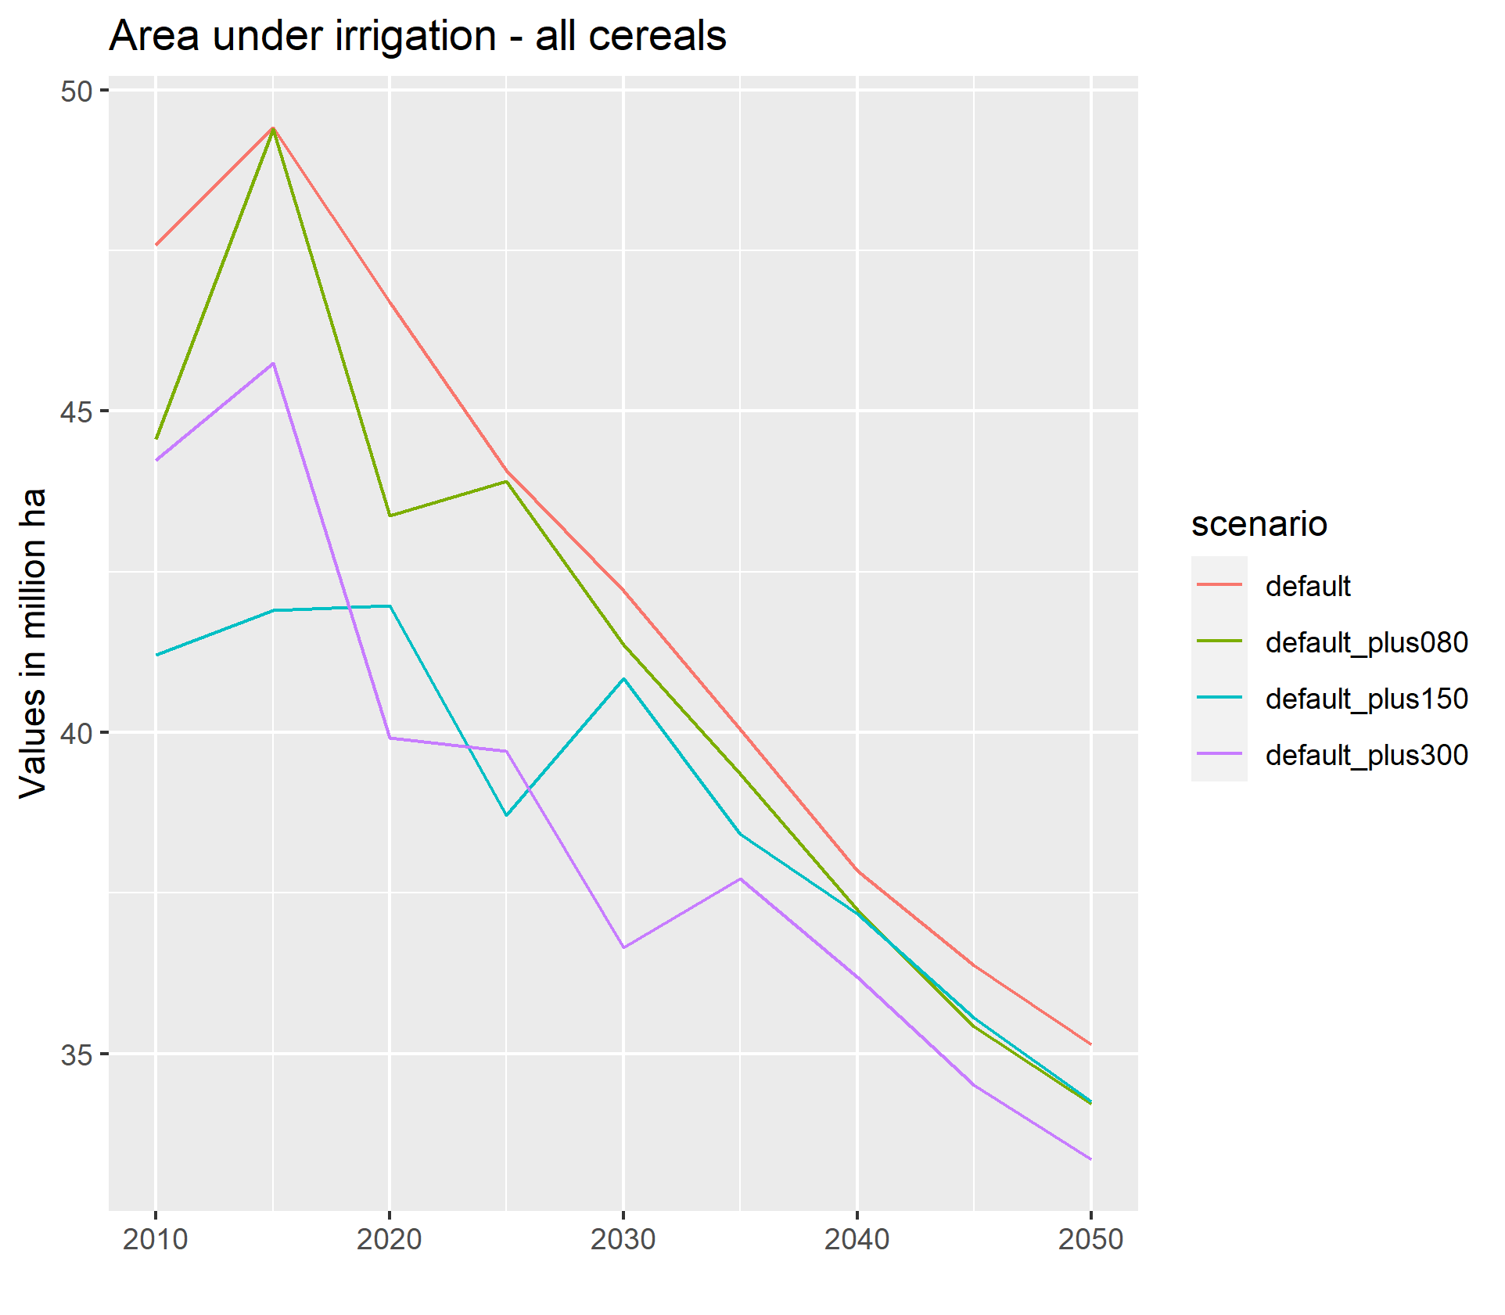

Whereas cereal production under irrigated areas declines from 42 mHa in 2020 to approximately 33 mHa in 2050 under the *default_plus150* scenario. This decline is higher in the *default_plus300* scenario implying that increase in costs of irrigation has a direct influence on irrigated cultivation. The difference in these impacts however, is different for different crops. Figure 2 below demonstrates this difference between rice and temperate cereals (primarily wheat) for India.

Figure 2: Total area under cereal cultivation by category (Irrigated)

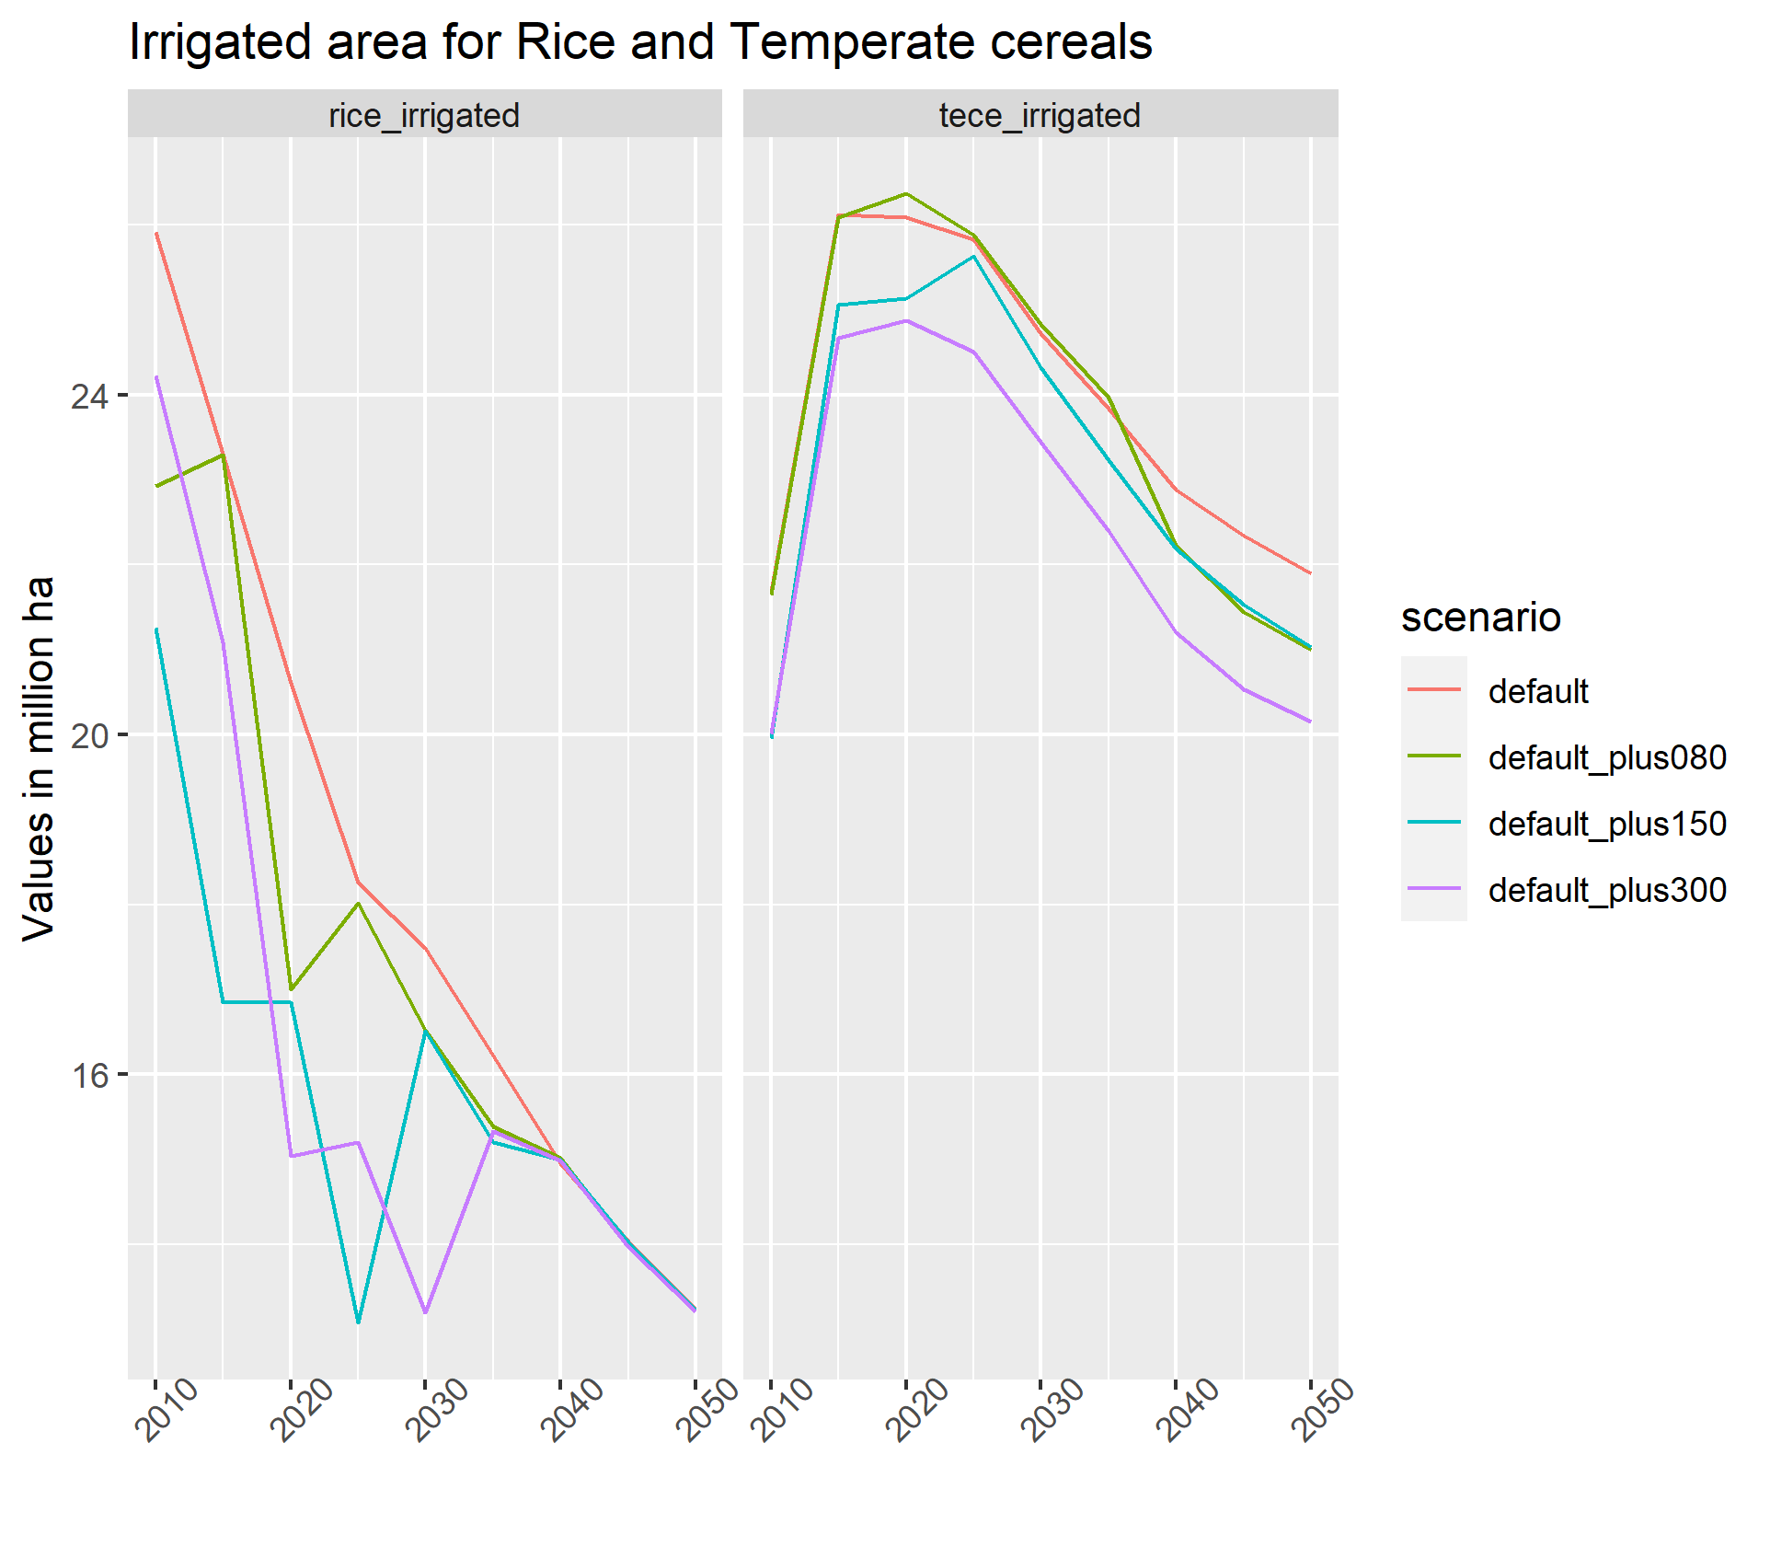

Cultivation of rice under irrigated area observes a sharp decline in all the three scenarios, but is restored in 2040 to 5 mHa. This is possibly due to the continued demand for rice to meet consumption demand of an increasing population. The same however, is not true for wheat which observes a continuous decline in irrigated area 2025 onwards. In 2050, the area under cultivation of irrigated temperate cereals is 21.9 mHA under the Business as Usual scenario whereas it is 20.1 mHA under the *default_*plus300 scenario. The model results predict that if water prices continue to rise, it will directly reduce the cultivated area of wheat under irrigated conditions without affecting production and yields.

Figure 3: Yields for rice and temperate cereals

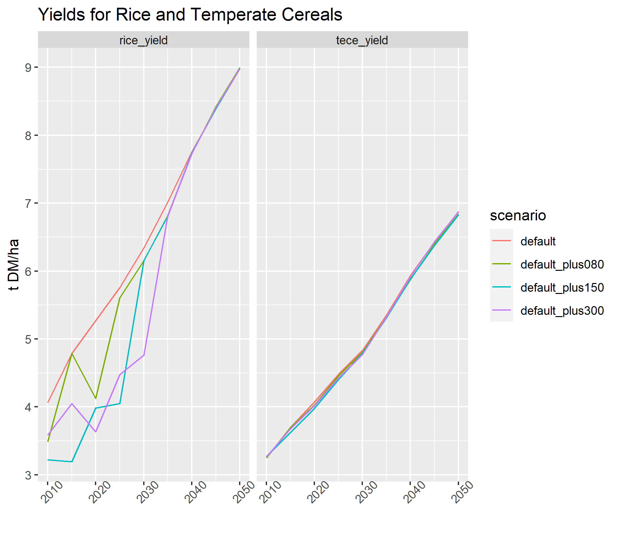

Although there are no implications on production of major crops such as rice and wheat, prices of both the crops observe increases in all the scenarios, as compared to the *default* scenario. While prices continue to decline over the years in all the scenarios, we find that increase in water prices have a direct effect on crop prices, as can be seen in Figure 4. In the *default* scenario, prices of rice decrease from 568 USD per tonne to 390 USD per tonne. For the *default_plus150* scenario, prices of rice per tonne reduced from 589 USD to 409 USD and similarly, for the *default_plus300* scenario, these prices reduced from 584 USD to 427 USD. A similar trend is observed in the prices of temperate cereals across all the scenarios.

Figure 4: Prices for rice and temperate cereals

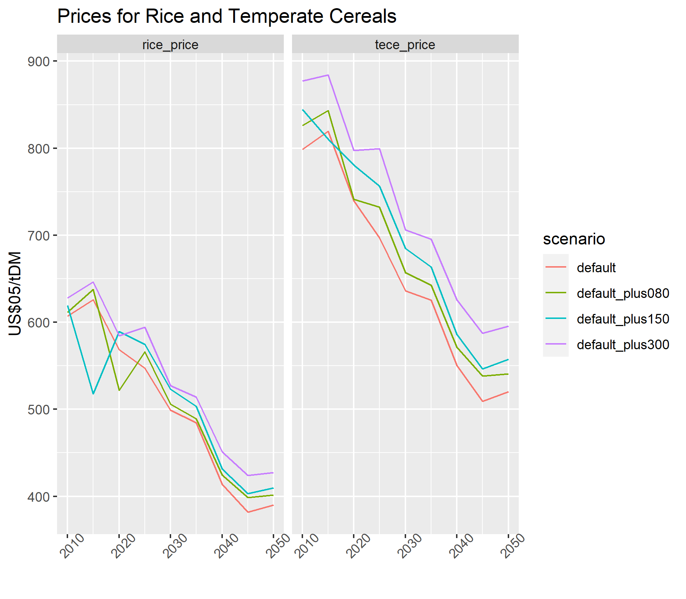

The effect of rising prices of major crops such as wheat and rice due to the increased factor costs can be seen in the food price index as well. Overall, in the model, the food price index demonstrates a decreasing trend, implying that as population grows and food production increases due to technological change, the purchase price of food products will increasingly decline as can be seen in Figure 5.

Figure 5: Food Price Index

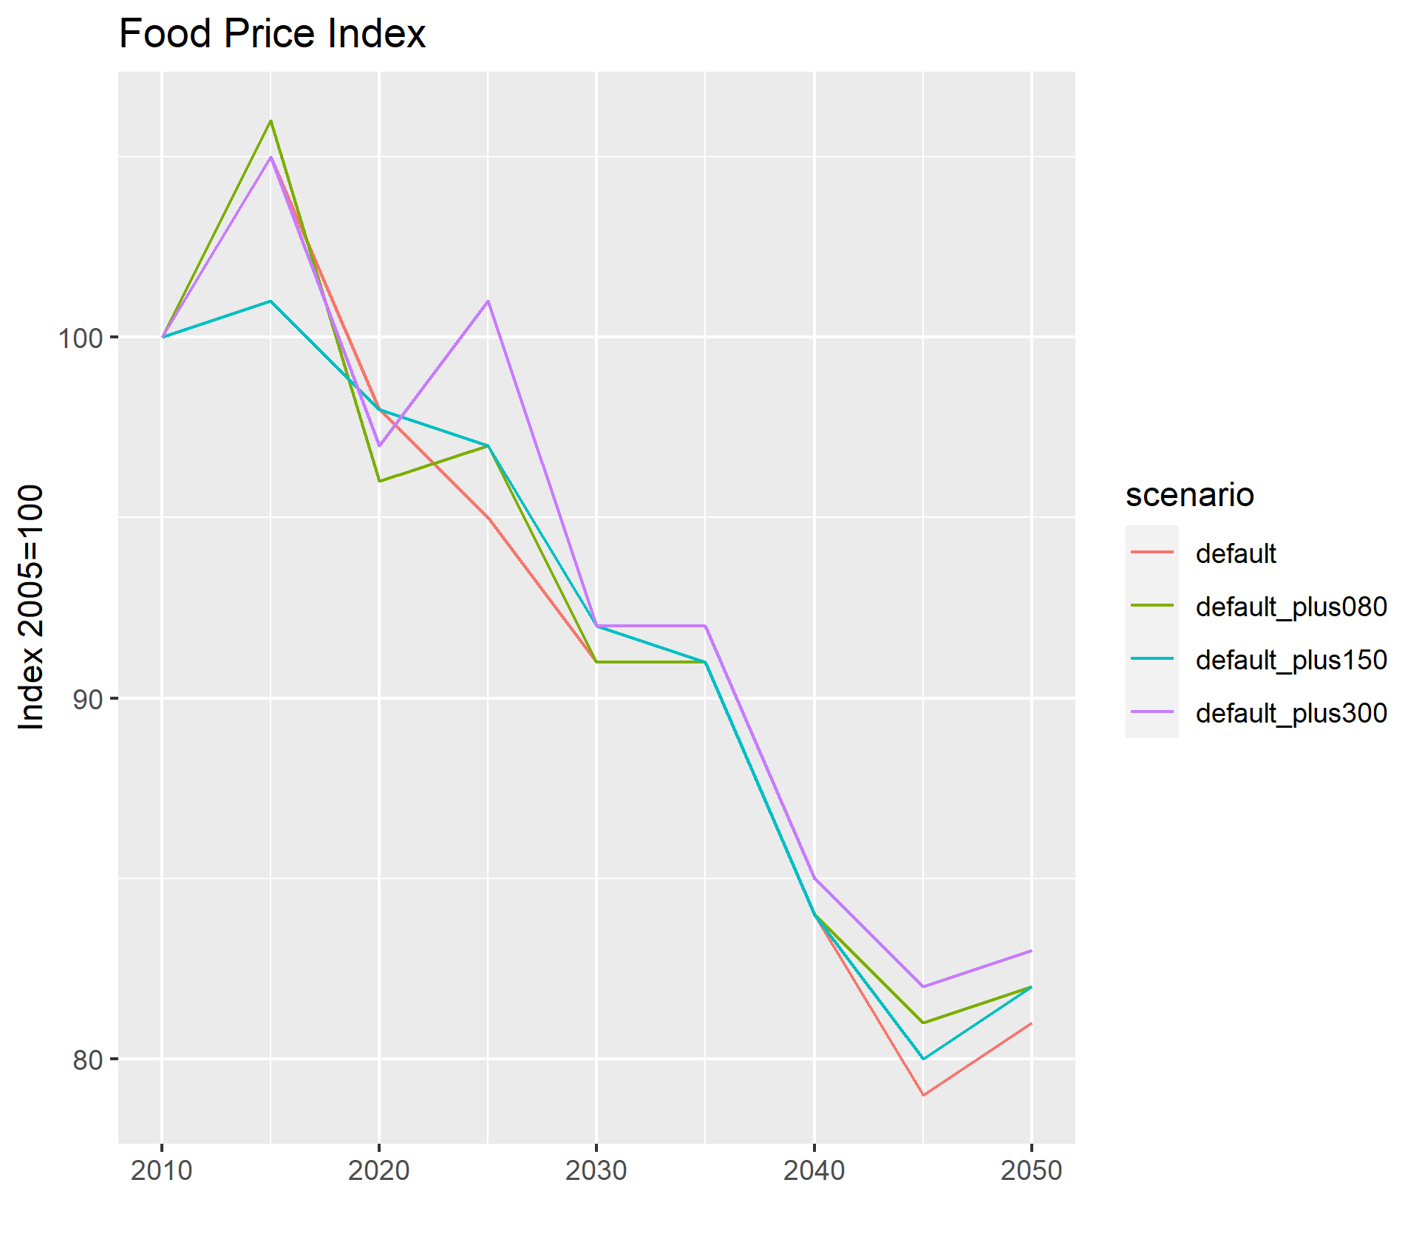

Our model allowed for free trade for products at the global level, but we do not observe any change in traded quantities of staple crops in the three scenarios. Similarly, there is no observed change in food demand of crops over the years across the scenarios.

At the spatial level, we are able to assess the transition in irrigated cropland across the country through the figures below:

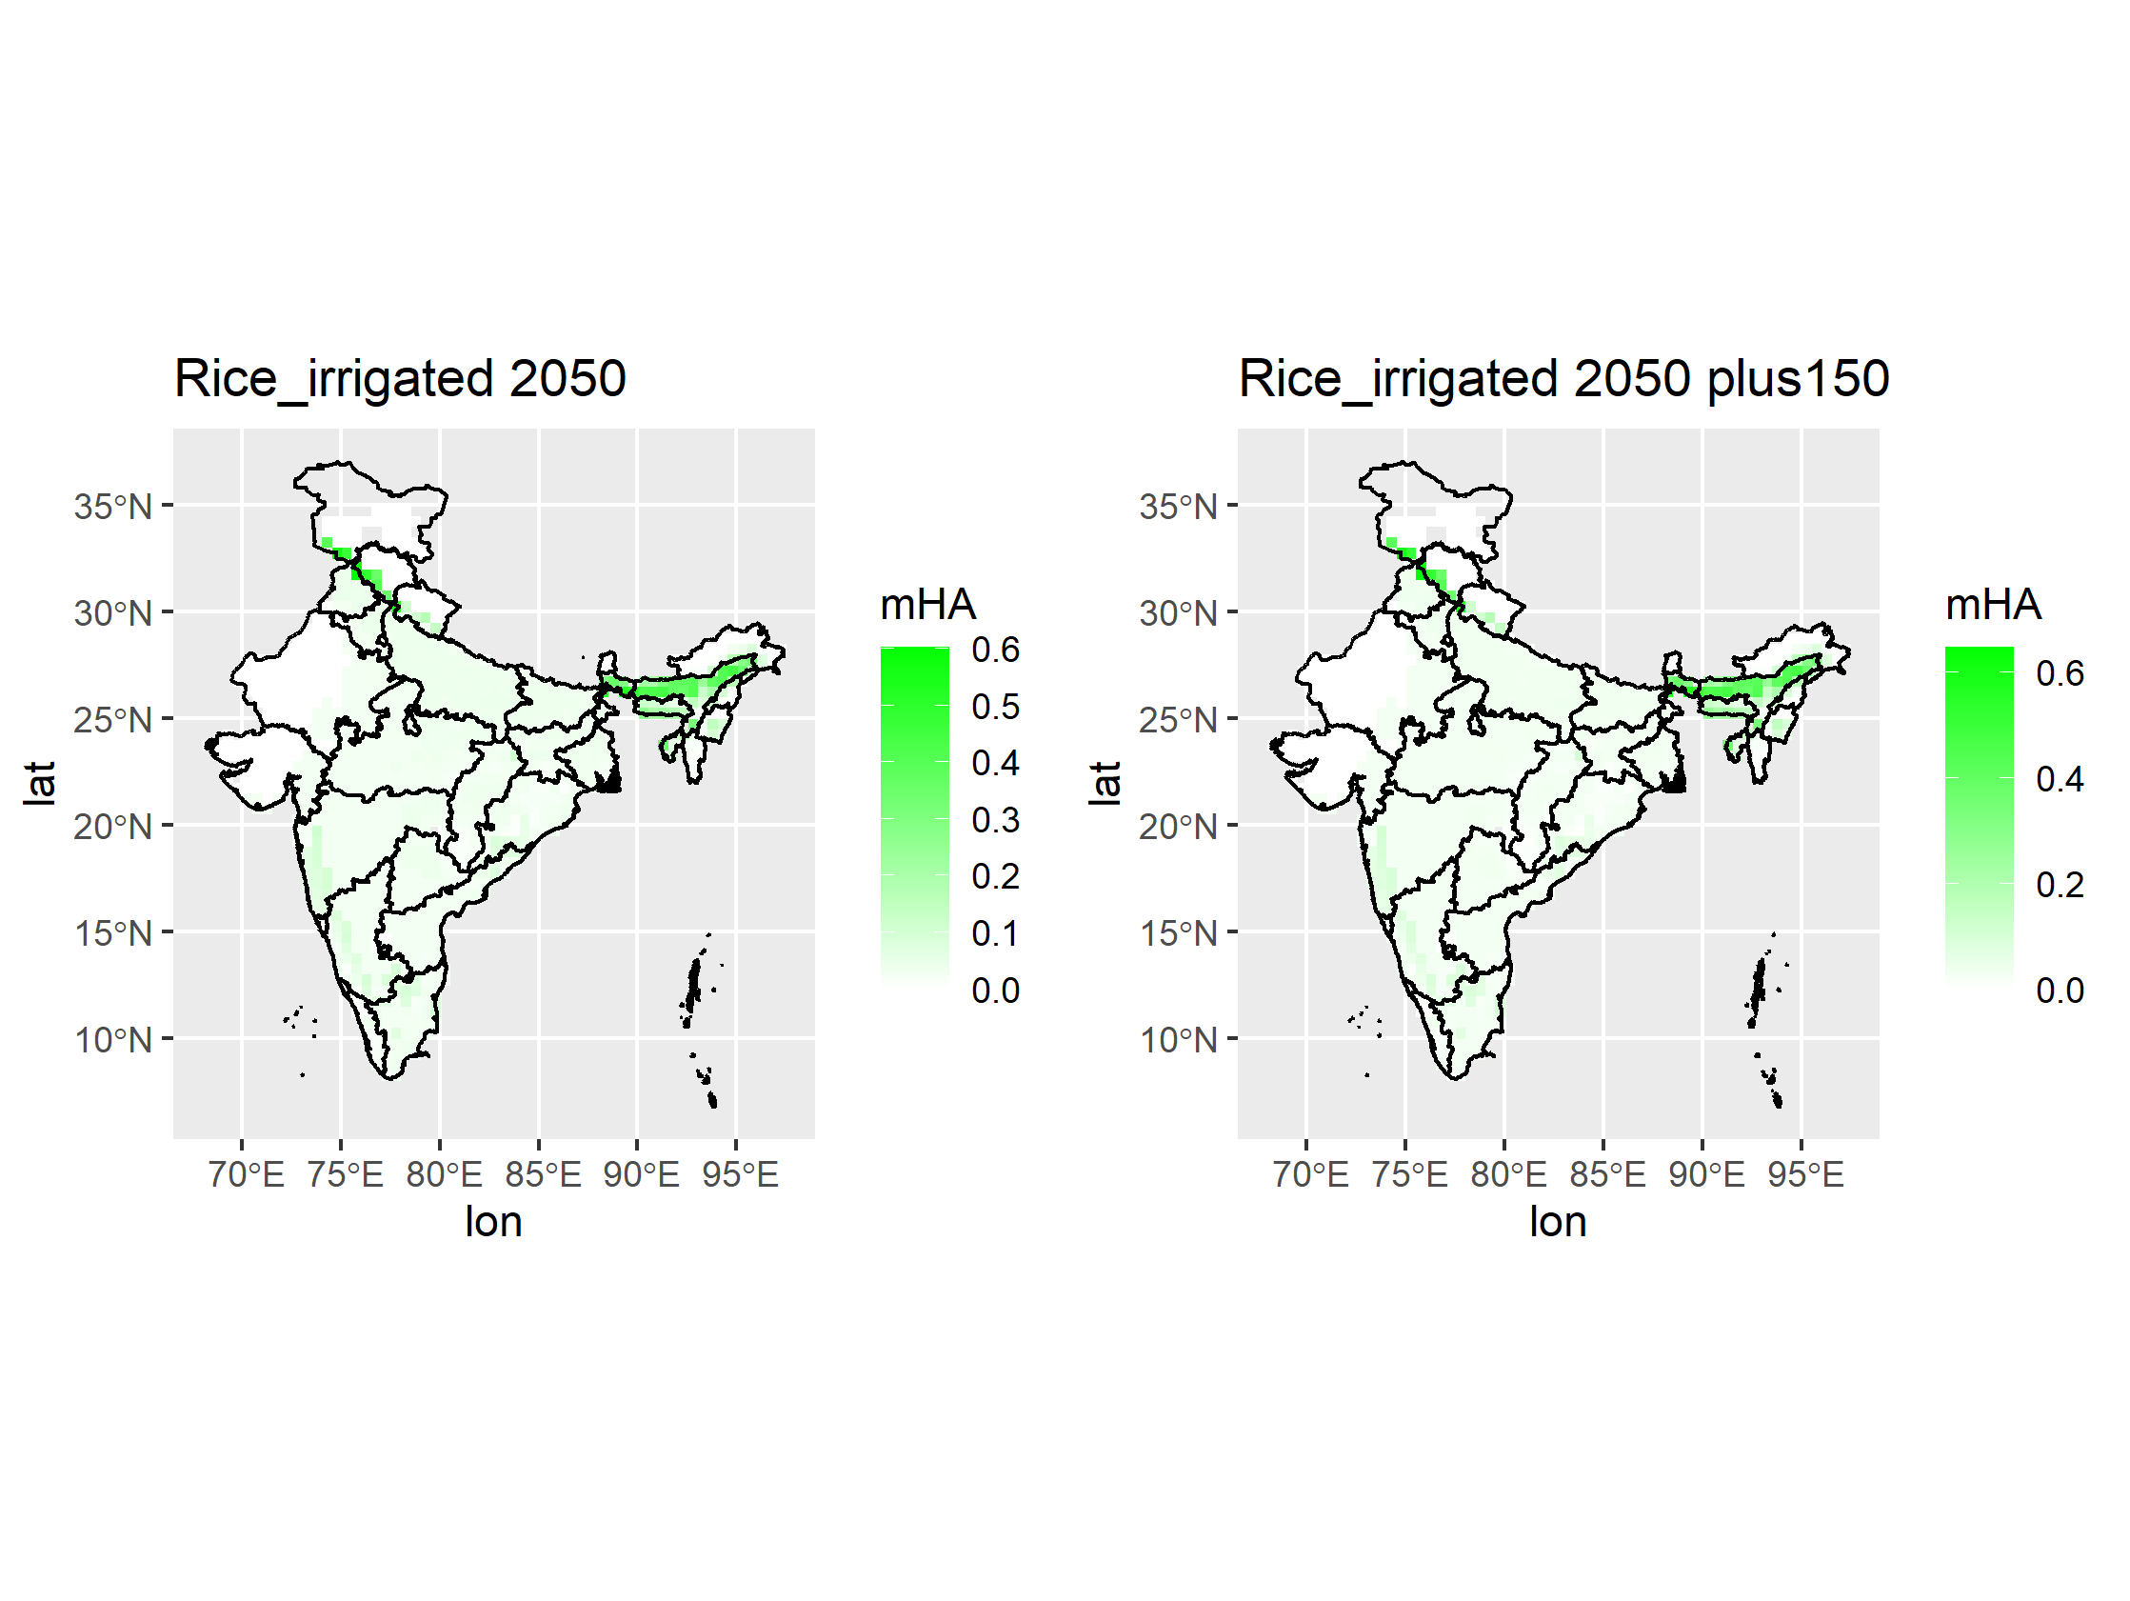

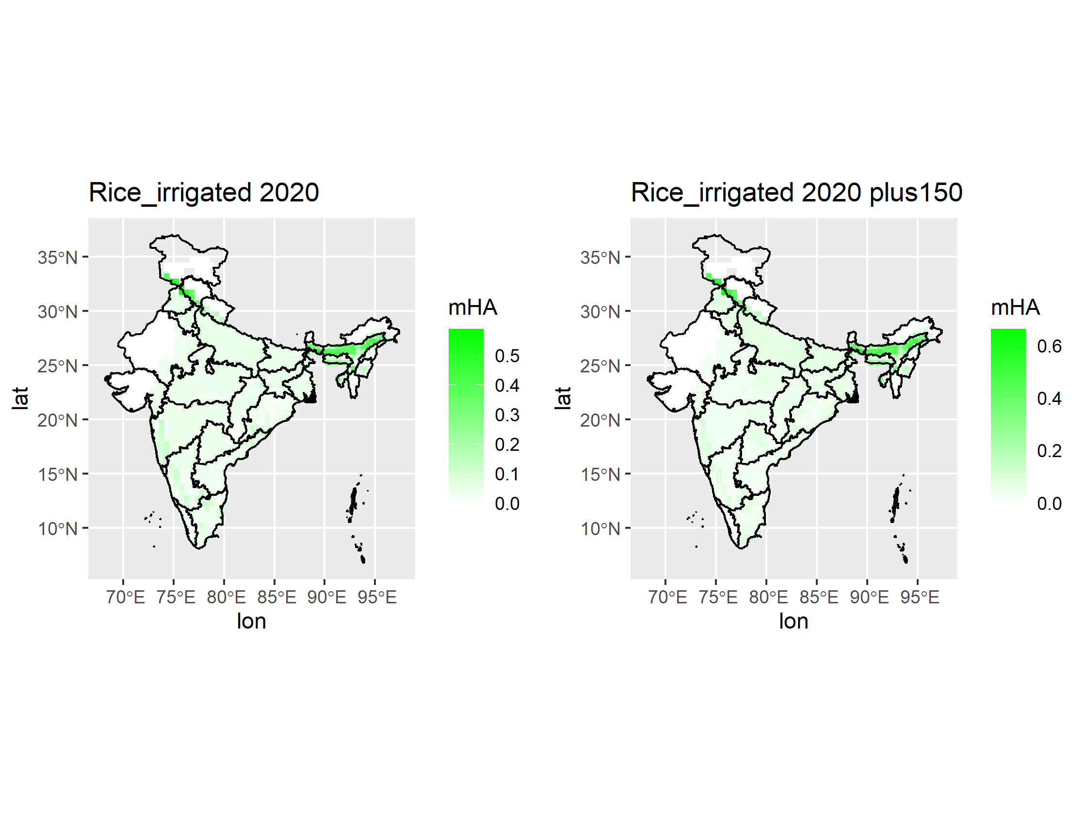

**Discussion**

Our results are in line with other studies observed for India, where we find that a reduction in irrigation water availability (through monetary policy changes or groundwater depletion) will cause a reduction in cropping intensity for cereal crops in India (Jain et al., 2021). This reduction is more so in the case of rice than wheat, thereby suggesting that irrigated wheat cultivation is less elastic as compared to rice and despite almost doubling of water prices, the cultivated area of wheat reduced by approximately 8%. We observe an increase in rise in prices of major food products despite a larger share in their contribution to food security in India. This has direct implications on food affordability for the larger and continuously growing population in the future.

Additional analysis needs to be undertaken to evaluate the intra-regional implications of the reduction in cultivated area of rice and wheat as well as increased population on consumers. Moving ahead, these analyses will be undertaken. The paper also does not account for change in water availability due to changing climate scenarios as this would have certain implications on the changing crop pattern systems in the country.

**Limitations**

In our model setup, regardless of the cellular productivity, the factor costs per area are identical for all cells within a region. This implicitly gives an incentive to allocate and concentrate production to highly productive cells. One limitation is that the model assumes that factor costs only depend on area and average productivity of a region. Productivity differences as well as capital investments made on regions to improve their productivity within a region are ignored. It is assumed that capital is perfectly mobile. Therefore, cases in which the cellular productivity levels affect factors costs are only partially accounted for. We also assume that irrigation efficiency remains same for all cells within a region, therefore, inter-regional disparities are not accounted for. Additionally, using physical production as a weight for the land rent assumes, that the economic output is equal for all units produced. In reality, this is not the case as prices for agricultural products vary strongly over the season. If irrigation can help to provide a commodity at a time where it is rather scarce and the price is high, the economic value of irrigation is higher than physical production numbers would suggest. As a result, this method of distinguishing rainfed and irrigated rents by physical production may lead to an underestimation of irrigated rent. The size of this effect is not easily quantifiable however and depends very much on the irrigation project under investigation.

**References**

Aeschbach-Hertig, W., & Gleeson, T. (2012). Regional strategies for the accelerating global problem of groundwater depletion. *Nature Geoscience*, *5*(12), 853–861.

Badiani, R., & Jessoe, K. (2014). *The Impact of Electricity Subsidies on Groundwater Extraction and Agricultural Production*. 41.

Badiani, R., Jessoe, K. K., & Plant, S. (2012). Development and the environment: The implications of agricultural electricity subsidies in India. *The Journal of Environment & Development*, *21*(2), 244–262.

Barik, B., Ghosh, S., Sahana, A. S., Pathak, A., & Sekhar, M. (2017). Water–food–energy nexus with changing agricultural scenarios in India during recent decades. *Hydrology and Earth System Sciences*, *21*(6), 3041–3060.

Bhanja, S. N., Mukherjee, A., Rodell, M., Wada, Y., Chattopadhyay, S., Velicogna, I., Pangaluru, K., & Famiglietti, J. S. (2017). Groundwater rejuvenation in parts of India influenced by water-policy change implementation. *Scientific Reports*, *7*(1). https://doi.org/10.1038/s41598-017-07058-2

Bondeau, A., Smith, P. C., Zaehle, S., Schaphoff, S., Lucht, W., Cramer, W., Gerten, D., Lotze-campen, H., Müller, C., Reichstein, M., & Smith, B. (2007). Modelling the role of agriculture for the 20th century global terrestrial carbon balance. *Global Change Biology*, *13*(3), 679–706. https://doi.org/10.1111/j.1365-2486.2006.01305.x

Briscoe, J., & Malik, R. P. S. (2006). *India’s water economy: Bracing for a turbulent future*. New Delhi: Oxford University Press.

Calzadilla, A., Rehdanz, K., & Tol, R. S. (2011). *The GTAP-W model: Accounting for water use in agriculture*. Kiel Working Paper.

Central Ground Water Board. (2019). *National Compilation on Dynamic Ground Water Resources of India, 2017*. Ministry of Jal Shakti, Department of Water Resources, Government of India. http://cgwb.gov.in/GW-Assessment/GWRA-2017-National-Compilation.pdf

Commission for Agricultural Costs and Prices (CACP). (2020). *Price Policy for Commission for Agricultural Costs and Prices*. https://cacp.dacnet.nic.in/ViewQuestionare.aspx?Input=2&DocId=1&PageId=40&KeyId=732

Cornish, G., Bosworth, B., Perry, C., & Burke, J. J. (2004). *Water charging in irrigated agriculture: An analysis of international experience* (Vol. 28). Food & Agriculture Org.

Dalin, C., Wada, Y., Kastner, T., & Puma, M. J. (2017). Groundwater depletion embedded in international food trade. *Nature*, *543*(7647), 700–704.

Dietrich, J. P., Schmitz, C., Lotze-Campen, H., Popp, A., & Müller, C. (2014). Forecasting technological change in agriculture-An endogenous implementation in a global land use model. *Technological Forecasting and Social Change*, *81*(1), 236–249. https://doi.org/10.1016/j.techfore.2013.02.003

Dietrich, J. P., Schmitz, C., Müller, C., Fader, M., Lotze-Campen, H., & Popp, A. (2012). Measuring agricultural land-use intensity—A global analysis using a model-assisted approach. *Ecological Modelling*, *232*, 109–118. https://doi.org/10.1016/j.ecolmodel.2012.03.002

Gómez‐Limón, J. A., & Riesgo, L. (2004). Irrigation water pricing: Differential impacts on irrigated farms. *Agricultural Economics*, *31*(1), 47–66.

Han, H., & Zhao, L. (2007). The impact of water pricing policy on local environment-an analysis of three irrigation districts in China. *Agricultural Sciences in China*, *6*(12), 1472–1478.

Jain, M., Fishman, R., Mondal, P., Galford, G. L., Bhattarai, N., Naeem, S., Lall, U., Balwinder-Singh, & DeFries, R. S. (2021). Groundwater depletion will reduce cropping intensity in India. *Science Advances*, *7*(9), eabd2849. https://doi.org/10.1126/sciadv.abd2849

Jain, M., Singh, B., Srivastava, A. A. K., Malik, R. K., McDonald, A. J., & Lobell, D. B. (2017). Using satellite data to identify the causes of and potential solutions for yield gaps in India’s Wheat Belt. *Environmental Research Letters*, *12*(9), 094011–094011.

Kayatz, B., Harris, F., Hillier, J., Adhya, T., Dalin, C., Nayak, D., Green, R. F., Smith, P., & Dangour, A. D. (2019). “More crop per drop”: Exploring India’s cereal water use since 2005. *Science of the Total Environment*, *673*, 207–217.

Lotze-campen, H., Müller, C., Bondeau, A., Rost, S., Alexander, P., & Lucht, W. (2008). Global food demand, productivity growth, and the scarcity of land and water resources: A spatially expliciti mathematical programming approach. *Agricultural Economics*, *39*(3), 325–338.

Meenakshi, J. V., Banerji, A., Mukherji, A., & Gupta, A. (2012). *Does Marginal Cost Pricing of Electricity Affect Groundwater Pumping Behavior of Farmers?* Paper submitted to 8th Annual Conference on Economic Growth and Development.

Molle, F., Venot, J.-P., & Hassan, Y. (2008). Irrigation in the Jordan Valley: Are water pricing policies overly optimistic? *Agricultural Water Management*, *95*(4), 427–438.

Mukherji, A. (2006). Political ecology of groundwater: The contrasting case of water-abundant West Bengal and water-scarce Gujarat, India. *Hydrogeology Journal*, *14*(3), 392–406.

Narayanan G., B., & L. Walmsley, T. (2008). *Global Trade, Assistance, and Production: The GTAP 7 Data Base*. Center for Global Trade Analysis, Purdue University. http://www.gtap.agecon.purdue.edu/databases/v7/v7_doco.asp

Qdais, H. A., & Al Nassay, H. (2001). Effect of pricing policy on water conservation: A case study. *Water Policy*, *3*(3), 207–214.

Ramaswami, B. (2019). *Agricultural subsidies: Study Prepared for XV Finance Commission*.

Ray, L. I. P., Mal, B., & Panigrahi, P. (2020). *Estimation of cost of pumping from a mini tubewell for agricultural usage*. *18*, 181–185.

Rodell, M., Velicogna, I., & Famiglietti, J. S. (2009). Satellite-based estimates of groundwater depletion in India. *Nature*, *460*(7258), 999–1002. https://doi.org/10.1038/nature08238

Rosegrant, M. W., Ringler, C., & Zhu, T. (2009). Water for Agriculture: Maintaining Food Security under Growing Scarcity. *Annual Review of Environment and Resources*, *34*(1), 205–222. https://doi.org/10.1146/annurev.environ.030308.090351

Scott, C. A., & Shah, T. (2004). Groundwater overdraft reduction through agricultural energy policy: Insights from India and Mexico. *International Journal of Water Resources Development*, *20*(2), 149–164.

Singh, K. (2012). Electricity subsidy in Punjab agriculture: Extent and impact. *Indian Journal of Agricultural Economics*, *67*(902-2016–66726).

Tiwari, V., Wahr, J., & Swenson, S. (2009). Dwindling groundwater resources in northern India, from satellite gravity observations. *Geophysical Research Letters*, *36*(18).

Yi, S., Wang, Q., & Sun, W. (2016). Basin mass dynamic changes in China from GRACE based on a multibasin inversion method. *Journal of Geophysical Research: Solid Earth*, *121*(5), 3782–3803.

Zaisheng, H., Hao, W., & Rui, C. (2006). Transboundary Aquifers in Asia with Special Emphasis to China. *United National Educational, Scientific, and Cultural Organization*, 10–18.

**Appendix**

Data sources used:

GTAP7 is the primary database for crop and water specific factor costs. Validation on these costs was done using

1. Statistical Abstracts for Punjab, Rajasthan, Haryana with time series data from 2000-2017
2. Central Groundwater Board of India
3. Literature on tariff rates in other states and their effects on irrigation water extraction

Table 1 highlights the extent of groundwater development from 2004 to 2017 in India.

Table 1: Assessment of groundwater development from 2004 to 2017

|  |  |  |  |  |  |  |
| --- | --- | --- | --- | --- | --- | --- |
| **Ground water Resources assessment 2004 to 2017 (bcm)** | | | | | | |
|  |  | **2004** | **2009** | **2011** | **2013** | **2017** |
| 1 | Annual Replenishable Ground Water Resources | 433 | 431 | 433 | 447 | 432 |
| 2 | Net Annual Ground Water Availability | 399 | 396 | 398 | 411 | 393 |
| 3 | Annual Ground Water Draft for Irrigation, Domestic & Industrial uses | 231 | 243 | 245 | 253 | 249 |
| 4 | Stage of Groundwater Development | 58% | 61% | 62% | 62% | 63% |
| Source: Central Ground Water Board 2017 | | | | | | |

The inter-linkages between consumption of groundwater and its implications on food and energy resources have been identified by (Barik et al., 2017) in the figure below.

Figure 1: Inter-linkages between water-food-energy in a changing climate

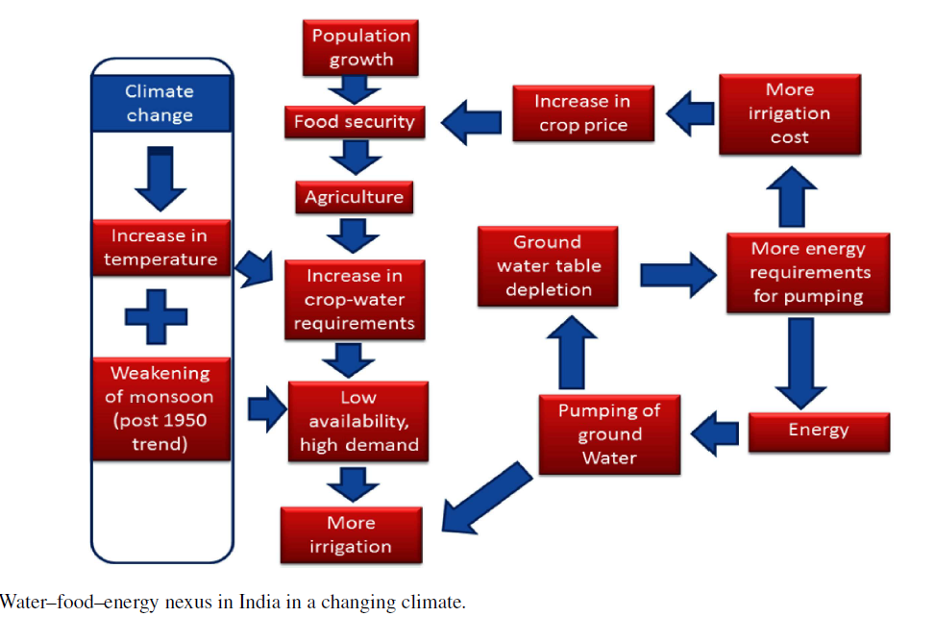

Source: Barik et.al., 2017

1. https://www.in2013dollars.com/us/inflation/2005?endYear=2017&amount=20
2. https://www.financialexpress.com/economy/cerc-calculates-fy19-average-power-price-at-rs-3-60-per-unit/1601276/
3. https://www.statista.com/statistics/808201/india-cost-of-state-electricity-supply/